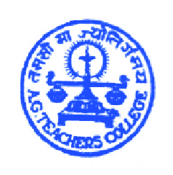
A.G.TEACHERS COLLEGE(CTE)
Commerce Six Road,
Navrangpura, Ahmedabad – 09.
‘A’ graded by NAAC – U.G.C.
NEWSLETTER – AUGUST 2013

For the academic year 2013-14, the college started functioning on 1st August 2013. 95 students opted for A.G.Teachers College in the 1st round and 5 were given admission through reshuffling. Thus, the final list comprised of 100 enthusiastic trainee teachers who are now termed as “AGIANS”. The first week of August was dedicated to the orientation program for theory and practicals. Trainees have successfully acquired skills through microteaching. Trainees observed demonstration lessons and are in process of using methods and techniques through simulation.
The first step towards change is AWARENESS..!!
A Glimpse of Seminars held in August Month
Study Abroad Awareness Seminar in association with K. T. International and UDISHA (12-08-13)
The teaching system of U.S is mainly based on the latest technology. Thus teaching and studying abroad would give an exposure to using the new teaching technologies. The direct and indirect training received by using such latest technologies becomes highly beneficial to the teachers/students. Major advantages of studying abroad were highlighted which included Money, Work Satisfaction, Exposure, Respect and an opportunity of pursuing further studies abroad.
“Man can do the best when he is under pressure”
When you are alone, you become independent. Your personal and presentation skills improve. You can feel the change!
The seminar was concluded with an interesting example of a Father and his small daughter - A man was reading the newspaper while his little daughter came and disturbed him continuously. The man was ridiculed with his daughter’s behavior and so he tore the newspaper into many pieces and gave the kid to stick the pieces correctly in order to reconstruct the newspaper. He thought the task assigned by him will keep the kid occupied for few hours, but to his astonishment the girl reconstructed the newspaper within 2-3 minutes. He asked her, how did she do it so quickly and correctly? The girl replied that the newspaper had Salman Khan’s picture at the back side. She joined Salman Khan’s picture correctly and the task was done.
The moral presented through this story was – “When the task is difficult, think of the alternative”

An organ donation awareness initiative by SHATAYU – The Gift of Life!! (03-09-13)
Food for thought – “A person can help up to 50 people if he/she decides to donate all the organs/tissues.”
The students were enlightened about “Organ Donation” with the help of a power point presentation which covered various topics like – what is organ donation, who can be a donor?, types of donations, difference between coma and brain death, when must organs be removed?, How can a person become a donor?, Common myths pertaining to organ donation and Transplantation of Human Organs Act, 1994 was discussed in detail.
Seminar on Solid Waste Management by Ahmedabad Municipal Corporation (06-09-13)
Whatever we use creates WASTE!! From the time we wake up in the morning, we start creating waste in different forms. Every person at an average creates 500 grams of waste every day. Along with growth in the population, rapid growth in the waste has also been notice. Figures depicting increase in the amount of waste in Ahmedabad were shown. It has become difficult to dump so much of waste. Gujarat stands at the 8th position in India for creating maximum waste. 1500 kilograms of waste is cleaned by Ahmedabad Municipal Corporation on daily basis.
Aiming to make Ahmedabad a “Zero waste city by 2031” - Ahmedabad Municipal Corporation undertakes various tasks like organizing Seminars, Rallies and Street Shows for creating awareness among people.
Students were provided knowledge about the types of waste i.e. Biodegradable and Non-Biodegradable, along with the list of difficulties faced due to excessive garbage. Students were also provided suggestions of how to create minimum waste and maintain cleanliness in our surroundings. The seminar included 2 motivational short films that encouraged students to keep the surroundings clean.
Growing waste is becoming a dreadful problem. If we “the youth” decide to work on this problem, we can bring an end to it and make Ahmedabad a zero waste city at the earliest. But for this we all should realize our responsibility and rather than throwing waste anywhere and everywhere, we should throw it only in a DUSTBIN. This should not be kept limited to ourselves, we should also try to teach and motivate everyone around us to keep the city clean. “Each One, Teach Ten” should become our motto.
CTE Centre
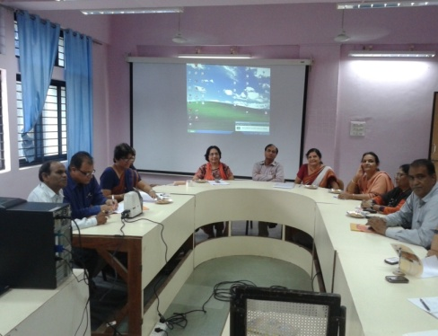
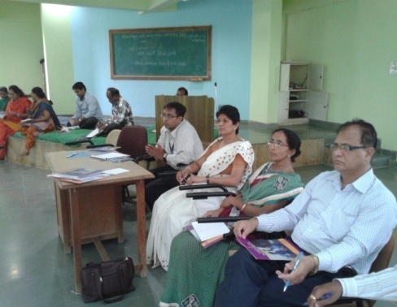
“People in this country have been slow to recognize that education is a profession for which intensive preparation is necessary as it is in any other profession”. This concern expressed in the University Education Commission (1948-49) Report is alive in today’s relevance. Preparing one for a profession is an arduous task and it involves action from multiple fronts and perspectives. Training of teachers is a major area of concern at present as both pre-service and in-service training. The world is in a transit mode and it is high time that all profession think about their stand globally.
A.G.Teachers College was upgraded by CTE (college of teacher training) in 1989-90 to share the responsibility of quality enhancement at pre-service and in-service teacher training.CTE centre organizes various need base training programs for school teachers-principals and trainees. There altogether eight CTE centres functioning in Gujarat state. A joint review mission (JRM) is arriving to Gujarat to observe the functioning of all CTE centres. In this direction faculty members of college attended a meeting at GCERT and DIET. JRM is expected to visit the college during 13th sep to 20th sep. and review the program.
Manifestations
- Humanitarian Education – Need for Society !! (By: Vanadana Didvania)
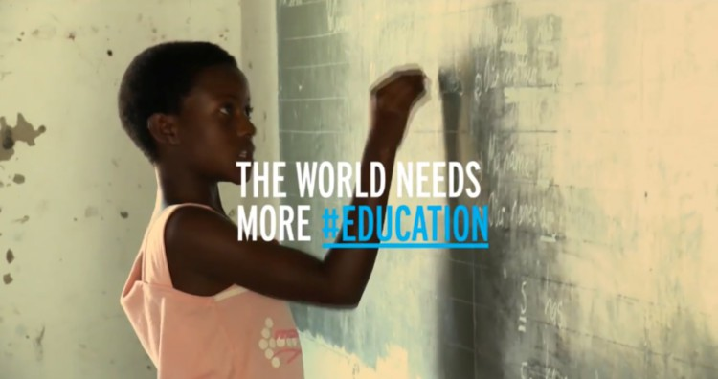
Humanitarian education is an area of learning that concentrates on the desire or impulse to save lives, protect human dignity and reduce suffering. It particularly relates to offering assistance to others in n emergency or crisis and is also used to refer to the skills, knowledge and attitudes needed for individuals and communities to help themselves. In the UK it may appear within curriculum subjects such as citizenship and Personal, Social and Health Education. It began to be developed and encouraged in the UK by the British Red Cross during 2005.
- Goals and outcomes
The goal of humanitarian education is that communities increase their resilience and that individuals and groups are more confident, able and willing to help themselves and others when faced with a crisis.
- Different from other forms of education
Its origins in the International Red Cross and Red Crescent Movement mean that humanitarian education is sometimes confused with development education or global education, or simply teaching about the work of aid or development NGOs. Adherents also stress that humanitarian education is philosophically and practically distinct from human rights education, since the humanitarian impulse is founded on needs rather than rights or entitlement.
Humanitarian education is linked to, but distinct from, education about international humanitarian law, often referred to as the laws of war. Aspects of IHL (international humanitarian law) are often topics within humanitarian education.
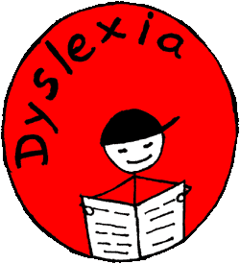
- Dyslexia – Sensitizing Society !! (By: Saima)
- What is Dyslexia?
Dyslexia is a learning disability that causes an individual to struggle with reading and writing. It can also affect other areas of a person's life: focus, memory skills, and organization. When you understand how to teach a dyslexic child, you can help build their self-awareness as well as their cognitive skills by using teaching methods. Some of the famous dyslexic people include Albert Einstein, Thomas Alva Edison, Sir Isaac Newton , Steve Jobs, Michael Faraday, Leonado Da Vinci etc.
- How to Teach a Dyslexic Child?
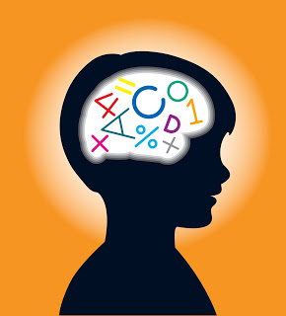
- Utilize a multi-sensory approach to teaching which includes use of touch, sight, movement, and sound. So that engages their motor and auditory skills.
- Incorporate fun activities into their learning time Because this makes learning more fun and rewarding, as it gives them a sense of accomplishment.
- Visual cues help individuals with dyslexia to understand so use color intentionally.
- Since dyslexic children may struggle with short-term memory, Repeat yourself often.
- Model organizational structures.Help individuals with dyslexia to develop organizational skills that will benefit them for the rest of their lives and Encourage peer tutoring.
- Utilize appropriate technology. Games, word processors, voice activated software, and digital voice recording can all be very useful for a child with dyslexia.

Upcoming events:
To get refresh from daily routine educational visit is to be planned. Seminar on various topics are to be organised to enhance their softskills. Open discusion on “empowered Women of India” will be held under the banner of CWDC. Debate competition will be organized for the celebration of “ Nashabandhi Saptah” on 3rd October.

