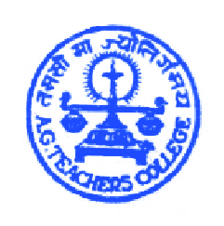
A.G.TEACHERS COLLEGE,
Commerce Six Road,
Navrangpura, Ahmedabad – 09.
‘A’ graded by NAAC – U.G.C.
NEWSLETTER – SEPT 2013

The dream begins with a teacher who believes in you…..
“Guru Brahma, guru vishnu, guru devo maheswaraha, guru shakshat parabrahma tatmaishree guruwe namaha.”
5th September, 2013
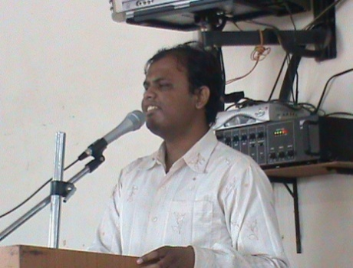
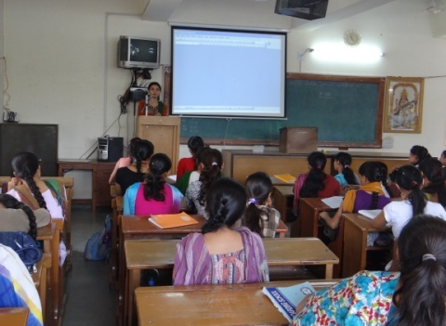
The above mentioned Sanskrit shlok shows that a teacher is given the importance of God in Indian culture. Teachers are a significant part of everyone's life. They show us the right path and groom us to become a better citizen and a better person. They teach us to face the most difficult challenges of life and get through them, easily. Teacher's Day is celebrated with great enthusiasm in many parts of the world. The day is dedicated to teachers, who play a prominent role in the life of their students. Teacher's Day is a wonderful opportunity for the students to extend their sincere appreciation to their teachers, for being an influential part of their life. Teachers play an important role in the growth of students. The festival known as Teacher's Day seeks to celebrate this unparalleled contribution made by teachers, in the life of their students. The ceremonious occasion is celebrated in different ways at different places.
A.G.Teachers College celebrated the Teacher’s Day in a very dynamic fashion where various games were conducted for students. On this day “Agians” – Mr. V.T.Savani, Miss. S.B.Kharadi and Mrs. N.Y.Chasmawala played the role of their professors and taught paper A-501 (Teacher in Emerging Indian Society), A-502 (The Learner – Nature and Development) and A-503 (Principles and Techniques of Teaching and Learning) respectively. Miss N.Y.Chasmawala also carried out the responsibilities of Principal for that particular day. Miss D.J.Parihar and Miss. R.G.darji played the roles of clerks; Mr. K.G.Vaghela acted as the librarian and Mr. K.R.Vaghela along with Mr. M.M.Pakhandi enjoyed the duties of the peons. The day was fun filled as students showed their gratitude towards teachers by singing different songs, sharing their views on several inspirational topics, etc. The whole event was covered nicely by the two dynamic anchors – Mr. V.M.Solanki and Miss. S.G.Nair. At the end of the celebration all the teachers were presented flowers as the token of love and respect.
On this special day the students showed their reverence to their professors and made them feel special. Teacher's Day is a special occasion for students to honor their teachers and thank them for being the guiding light in their lives. Thus, this day was celebrated with great enthusiasm at A.G.Teachers College.
Formation of student union A.G.Teachers College (2013-14)
As per the rules of Gujarat University, A.G.Teachers College selected the student union on 16th September for the year 2013-14. Keeping in view all the perspectives, 14 students were selected as the members of the student union. Following are the names of the selected students:
- Neelam. Chasmawala (G.S)
- Dave Anjali (L.R)
- Barodiya Roopali
- Pakhandi Moej
- Jadeja Divyaba
- Patel Zalak
- Didvania Vandana
- Algotar Dushyant
- Vaghela Kamlesh
- Sindha Artiba
- Panchal Hiren
- Patel Mittal
- Kharadi Sumitra
- Saiyed Saima

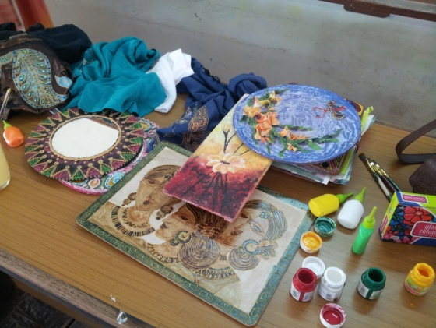
Hobby Ideas Workshop at A.G.Teachers College
18th September 2013
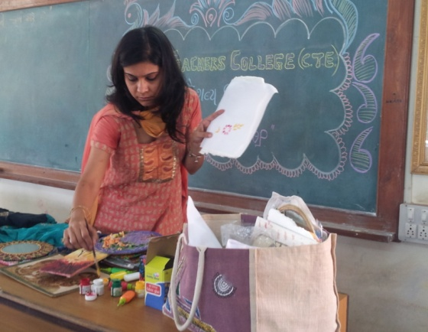
“Hobby ideas” is very popular on school and college level. It is a famous company having shops all over India. The shops contain ideas and stuff for creating best out of waste, colors, paintings, etc. A representative from hobby ideas visited A.G.Teachers College on 18th September 2013 during the college hours and showed the students various tricks and techniques of creating decorative stuff for daily usage, like – usage of fabric colors (T-shirt painting etc), Patch work, coloring various things like purse, folder, etc. Students were also introduced to several other interesting things like:

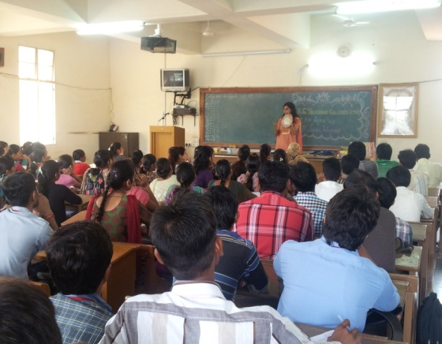
1. African Masks
2. Coffee Painting
3. Decorative Chains
4. Movable Rangoli
5. Glass Painting, etc
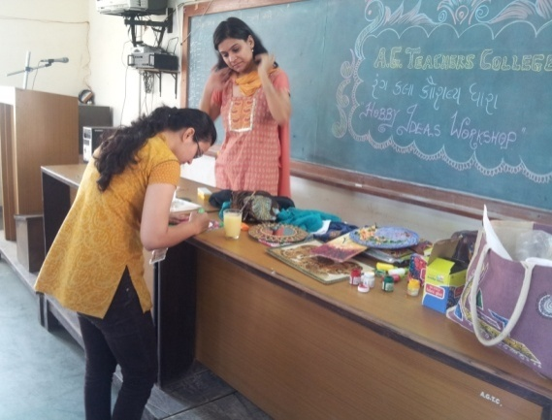
Students could learn to make the above mentioned things by attending the free workshops of hobby ideas. They just have to pay for the material that they use for making any of the mentioned items.
Few students went forward and tried 1-2 activities by themselves. Since all the students enjoyed the workshop, we are planning to organize such workshops regularly. Such workshops really enhance the creativity of students and encourage them to think in a different way.

Again’s visit to the IITE Seminar
24th September, 2013
All the trainee teachers of A.G.Teachers College visited Mahatma Mandir – Gandhinagar, to attend the seminar organized by the honorable Chief Minister of Gujarat Mr. Narendra Modi. Agians left from college at 9.00 a.m and reached Gandhinagar at 10.30 a.m. The seminar started at 11.00 a.m and ended at 1.00 p.m.
The Indian Institute of Teacher Education Act was passed in March 2010. IITE offers a four-year integrated course on Teacher Education. To lend material shape to the best educational philosophies from across the world, experts of national and international stature came together to design the curriculum of IITE. It was inaugurated by Shri Narendra Modi, Honorable Chief Minister, Gujarat, on June 30, 2011 amid a consortium of teacher education.
IITE epitomizes the extension of the knowledge tradition embedded in the rich intellectual and cultural heritage of India. IITE has been envisioned to introduce and initiate future teachers into the process of transformation into evolved beings who can lead and guide the children of tomorrow towards the knowledge century in true sense. IITE has a vision of empowering the nation and the world with teachers who can take the onus of shaping the next generation of students.

